A+ Computer Science GOLF GAME PART VI

Lab Goal : This lab was designed to teach you more object oriented programming and how to write a larger game.

Lab Description : Write the game logic for a multi-player Golf game. Each player will be dealt 4 cards. Each player will get the option to switch out 2 cards. Once everyone has switched out up to two cards, the score are tallied.

public class LotsOGolf
{
private ArrayList<Playerable> players; //you cannot have any other instance variables

public LotsOGolf()
{
// instantiate all of your instance variables
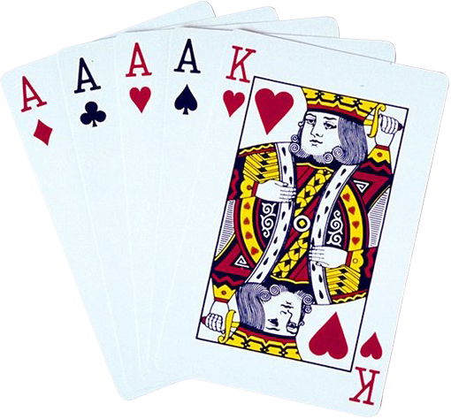
}

public void playGame() {
//all game code goes in here
}

public static void main( String args[ ] ) {
LotsOGolf game = new LotsOGolf();
game.playGame();
}
}

Game logic for multiplayer Golf
do{
1st – shuffle the deck of cards

2nd – loop through all of the players
everybody gets 4 cards – 1 card at a time

3rd – loop through the players – to see who wants to switch cards out
print out player’s hand value and cards
loop 1 times
ask who wants to switch out cards

4th – loop through all of the players
print out each player’s cards and hand value

5th – loop through all of the players
determine which person has the lowest hand value

6th – update the win total for the winners

}while another game is to be played

